Aquaponic System Monitor

This project started out as a swimming pool monitoring system that was re-purposed to monitor an aquaponic system. It measures the water temperature, PH, and Chlorine levels in the water. The output is displayed on a web page. If any of the readings exceed set limits it sends a text to notify you that the situation needs looking into.

Hardware:
The system runs on the Intel Edison Arduino board with a custom shield that simply makes connects to the sensors. The shield isn't strictly necessary you can see from the code what pins the sensors connect to so no schematic was needed it was just my alternative to cutting wires and changing connectors. The hardware has the capability of being powered by a 12V solar panel and backup battery that was used in the original swimming pool application but that isn’t used in the aquaponic application.
The PH and ORP (Oxygen Reduction Potential) sensors are from Phidgets.com. For a temperature sensor we simply used a thermister.

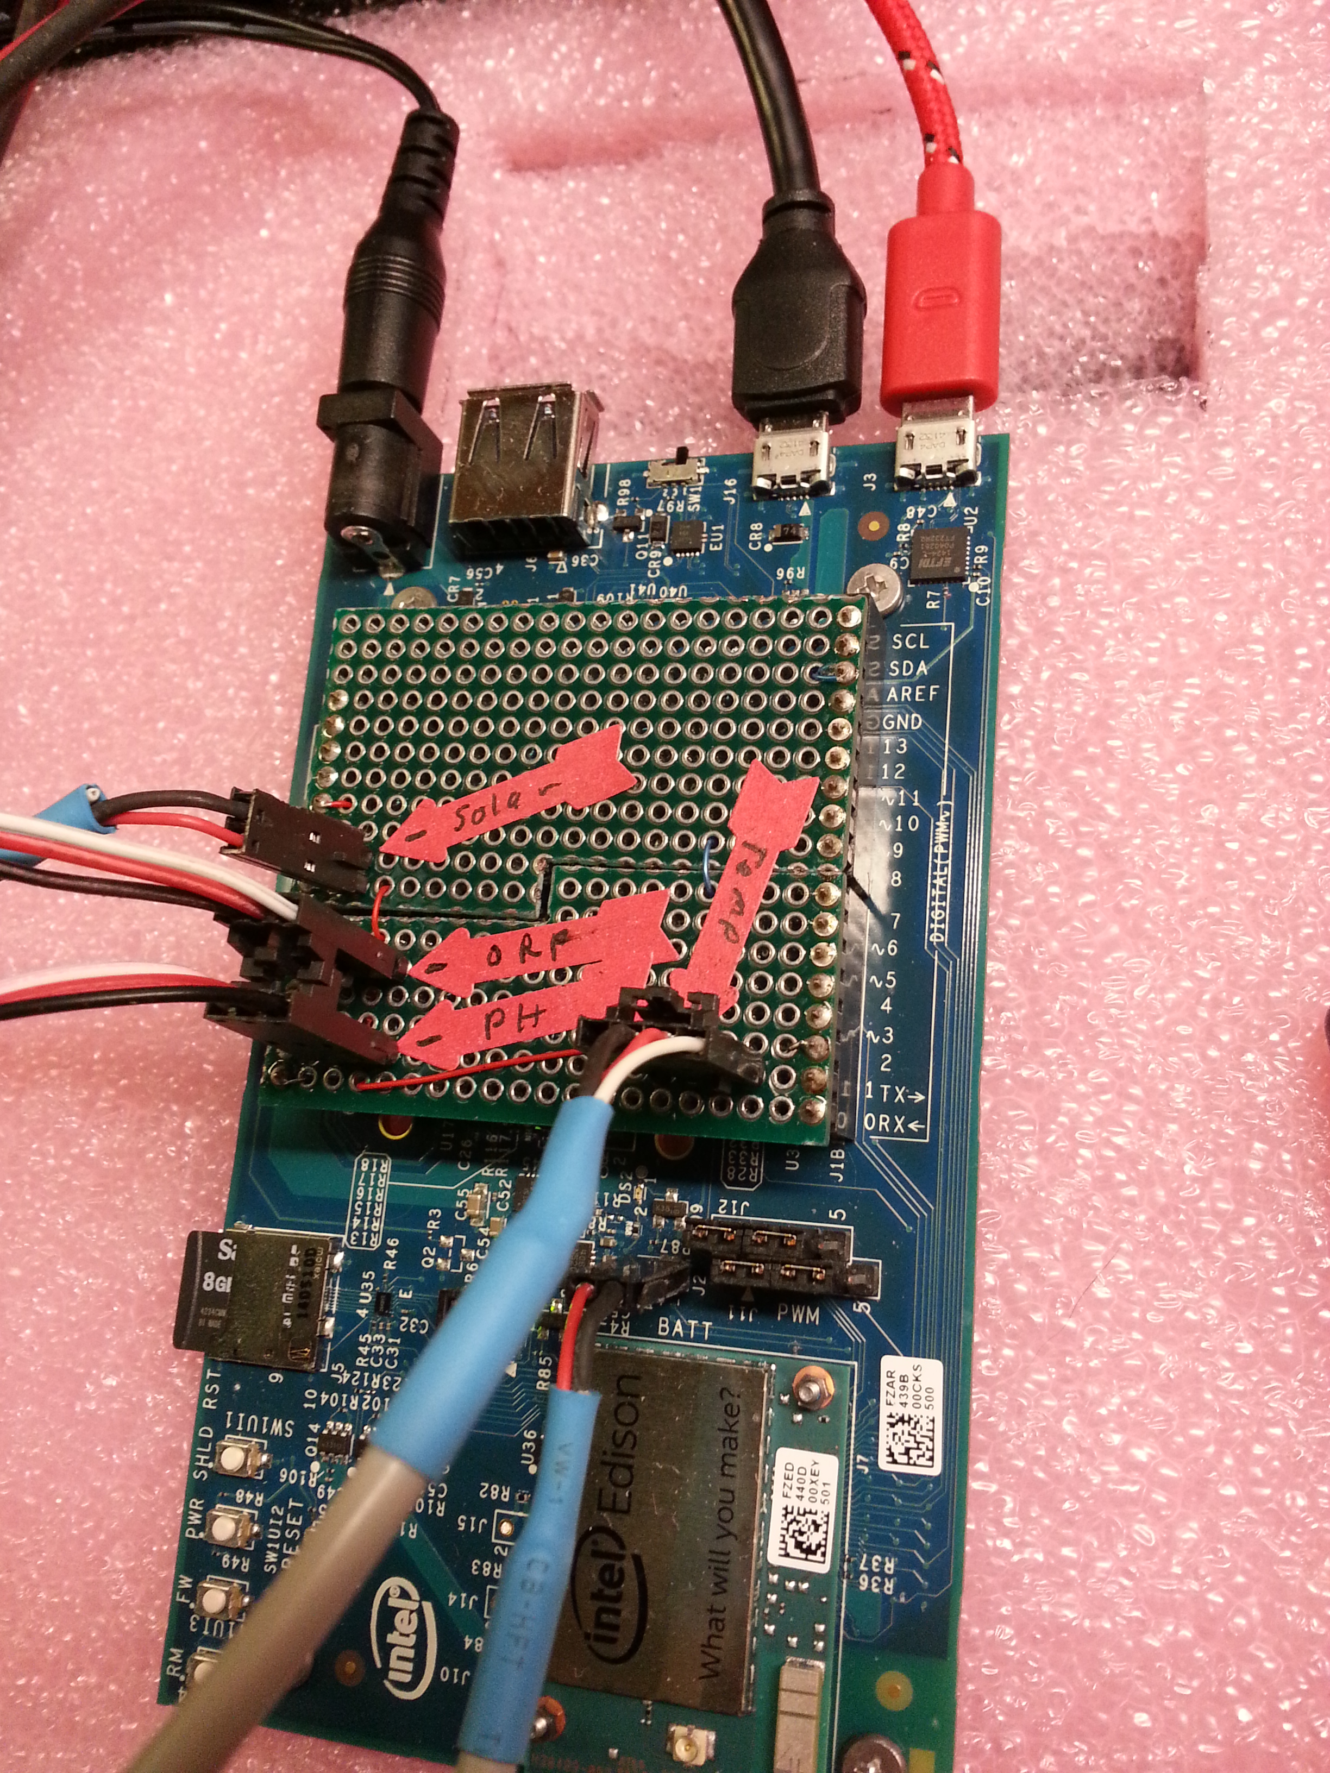

Software:
The application is written in Node JS. It uses Twillio to send text notification messages. To enable that feature you need to open a Twillio account (www.twillio.com) and update the file config_generic.js with your account information and rename it to config.js.

